Assianment-5

1. A signal *Xn[ejω]* is the STFT of a signal *xn[n]* using hamming window *w[n]*. Determine the minimum frequency sampling rate where length of the window Nw=100 sample, and Fs=10000Hz.
2. Figure-1 represents the magnitude of the discrete-time Fourier transform of a steady-state vowel segment. The envelope of the spectral magnitude is sketched with a dashed line. Suppose that the sampling rate is ***12 kHz*** meet the Nyquist rate. Determine the value of the first formant frequency.

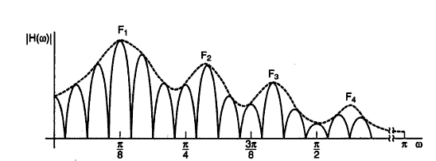

**Figure-1**

1. A signal *X(n,k)* is the STFT of a signal *xn[n]* and analysis is decimated in time by factor L, where w[n] is non-zero over its length Nw. *xn[n]* is invertible for which of the following condition
   1. The temporal decimation factor L≤Nw
   2. The frequency sampling interval 2π/N ≤ 2π/Nw
   3. The temporal decimation factor L>Nw
   4. The frequency sampling interval 2π/N ≥ 2π/Nw

A. (I) and (IV)

B. (I) and (II)

C. (III) and (IV)

D. (II) and (IV)

1. Which of the following is true for narrow band spectra?

(I) Time resolution low, frequency resolution high

(II) Time resolution high, frequency resolution low

(III) None of the above.

1. How many complex multiplications are required to compute the 1024 point DFT using FFT algorithm?

A. 10240

B. 1024x1024

C. 1024

D. 102400

1. Which of the following condition is necessary for complete recovery of the analysis signal in Overlap Add (OLA) method

A. Sum of all the analysis windows to add up to a constant

B. Frequency responses of the analysis filters should sum to a constant across the entire bandwidth.

C. Both of the above

1. A signal *Xn[k]* is the STFT of a signal *xn[n]* if the length of the DFT used is 1024 determine the frequency resolution. Where sampling frequency *Fs=10 kHz*

1. STFT analysis of a speech segment is required for noise reduction if the STFT analysis is done based on the Hamming Window of length 20 ms determine the maximum possible temporal decimation factor so that signal is completely invertible . Where sampling frequency *Fs=16 kHz*
2. Short-Time Fourier Transform Magnitude |S(nL,ω)| is compute for a speech signal segment with time decimation rate L=128 sample. If the signal is recover with modify decimation rate M=32 sample. Determine the speed-up of factor.
3. Main drawback of Time-Scale Modification of speech signal using Short-Time Fourier Transform Magnitude is

A. Pitch period mismatch at adjacent frames causes distortion

B. Occasional reverberant characteristic of synthesized signal are perceived due to lack of STFT phase control

C. There will no distortion at all